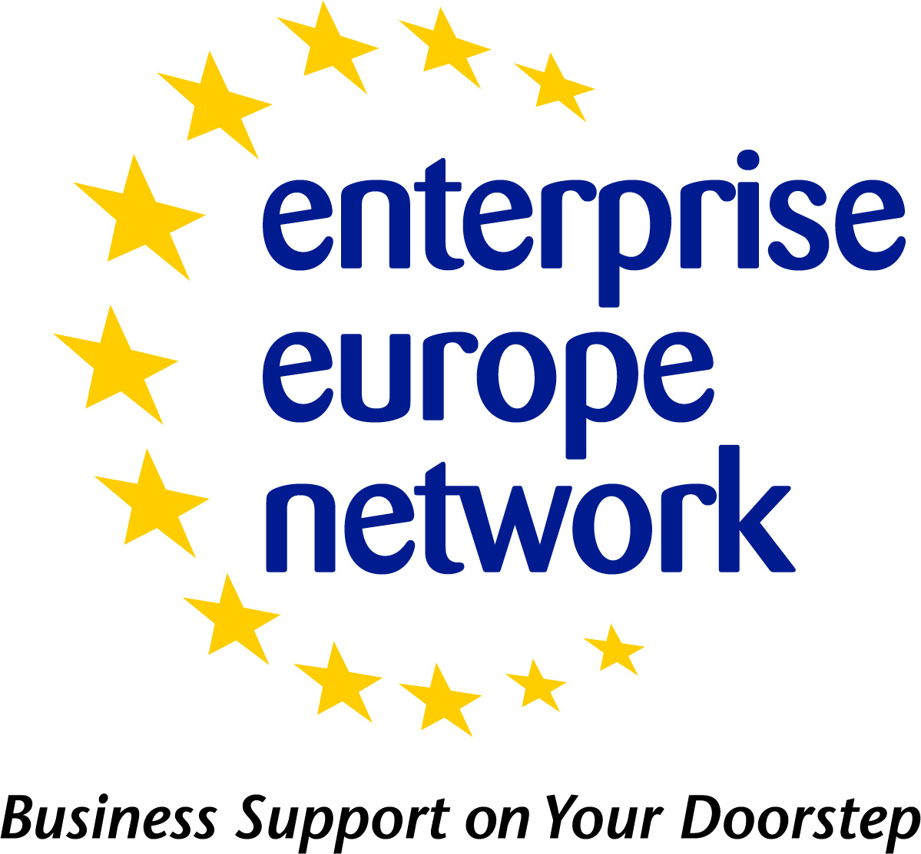 | Research Development Request - Profile Template
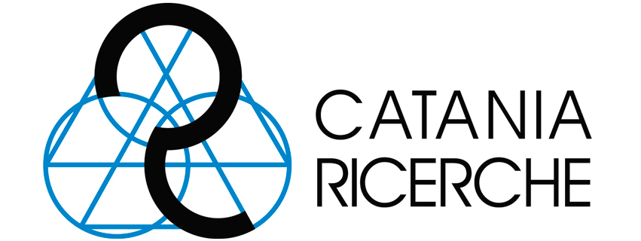 |   European Commission | 

Title*
Summary*  (1-500 characters) | The summary of a RDR should answer the following questions:  • Where, geographically, is the project coordinator from (if applicable)?  • What kind of organisation is the coordinator from?  • What is the R&D project about?  • What should be the field/technology/research area of the potential partner?  • What types of partnership are sought?  • In which programme will the R&D project be submitted? (e.g. Horizon 2020 subprogramme x or y, Eurostars, Interreg, COSME, ERANet x or y, private research etc.)
Advantages and Innovations  (50-2000 characters) | Describe clearly the innovative aspects, economic advantages/intended benefits and overall objectives of the proposed R&D project (max. 50 – 2000 characters including spaces).  • Explain briefly the potential impact the project will have (e.g. on the society – well-being, better balance, anticipation of emerging issues; e.g. on the market – better performance,increase of competitiveness; on the environment – less ecological impact, higher resource efficiency, better understanding of climate change). Provide qualitative and if possible quantitative arguments.  • Give a hint regarding the chosen approach to tackle the issue. Don’t give the solution, only a hint on the “how”!)  • Make clear how the project compares with other technologies (including those that are already on the market). Also include a brief description or bullet list of the main advantages. These could include performance, ease of use, economic benefits, comparison to competitive products etc.  • Consider elements such as performance, ease of use, need of specific know-how, or expertise to adopt the technology.  • Avoid generalities such as “best” or “unique”, but try to specify innovation by comparison with prevailing technologies.  • Whenever possible, quantify the innovative aspects or advantages of the technology/product putting the emphasis on explaining the “what” and not the “how”.
Stage of Development* | Already on the market  Available for demonstration  Concept Stage  Field Tested / Evaluated  Project Already Started  Project in Negotiations - Urgent  Proposal under development  Prototype available for demonstration  Under development / lab tested
Description*  (100-4000 characters) | Provide an introductory overview of the domain in which the R&D project is embedded and for what the results will be useful. Explain the context: what will be explored / developed in this R&D project, why, in which time frame, with whom, in which frame.  • Describe the issue to be tackled (provide scientific / technological explanation). Put the emphasis on explaining the “what” and not on the “how”.  • Provide information about the expertise or know-how of the organisation(s) already involved / foreseen for the project (The strength and complementarity of a consortium is key for the success of an R&D project!)  • Give information / references to framework conditions if the project will be submitted to public funding programme. Indicate e.g. a reference / a link where detailed information can be found to the related topic description in the related H2020 work programme, indicate when the project will be submitted, the foreseen duration, …)  • Do not include a sales promotion of the technology or know-how of the existing partners.  • Do not write your description with a specific market in mind; concentrate on the scientific and technological aspects of the R&D project.  • Whenever you use abbreviations, please make sure that full names are given, as well as further explanation (if necessary) is provided.  • Please make sure that your profile is understood by other Network Partners who may not be the experts in this particular R&D / scientific / technology field.  • Avoid technical jargon.
Technical Specification or Expertise Sought | Clearly specify the technical requirements and other roles that the potential partner would fulfil within the project.
IPR Status  Note: Multiple fields can be selected. | Copyright  Design Rights  Exclusive Rights  Granted patent or patent application essential  Other (registered design, plant variety, etc.)  Patent(s) applied for but not yet granted  Patents granted  Secret Know-how  Trade Marks
Already Engaged in Trans - national Cooperation? | Yes  No
Type and Role of Partner Sought* | Include all information pertaining to the type of partner such as whether they are from industry, academic or research organisations, etc.
Framework Programme*
Call Name*
Evaluation Scheme*
Coordinator Required | Yes  No
Deadline for the Call*
Funding Scheme* | Collaborative Projects  Coordination and Support Actions  Individual projects: Support for "frontier" research  Networks of Excellence  Research for the benefit of specific groups (in particular SMEs)  Support for training and career development of researchers
Web link to the Call
Project title and acronym

